CSA1509-Cloud computing and Big Data Analytics
Name : yuvan shankar L
Reg.no: 192511072

EXP 13:Create a Virtual Machine with 1 CPU, 2GB RAM and 15GB storage disk using a Type 2 Virtualization Software.
Aim:
To Create a Virtual Machine with 1 CPU, 2GB RAM and 15GB storage disk.

Steps:
- Download VMware software and install it as Type-2 Hypervisor.
- Download Ubuntu or tiny OS as ISO image file.
- In VMware workstation → Create new VM
- Do the configuration based on given conditions.
  - Change number of processors to 1.
  - Change Memory to 2 GB and storage to 15 GB.
- Created a virtual Machine.
- Launch the VM.
Implementation:
- Download and open VMware software.
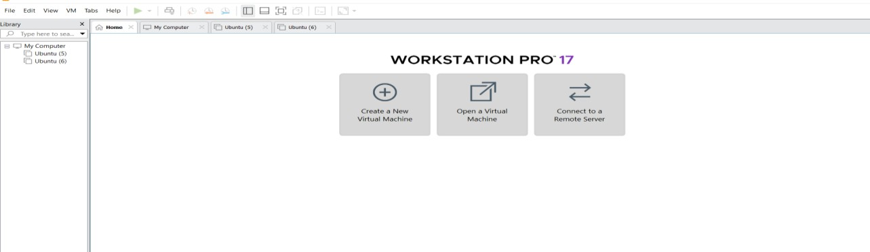

- Create a new VM
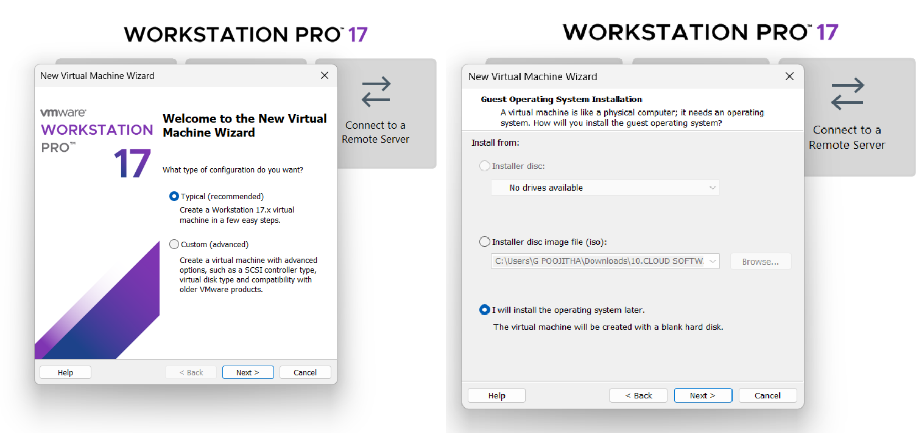
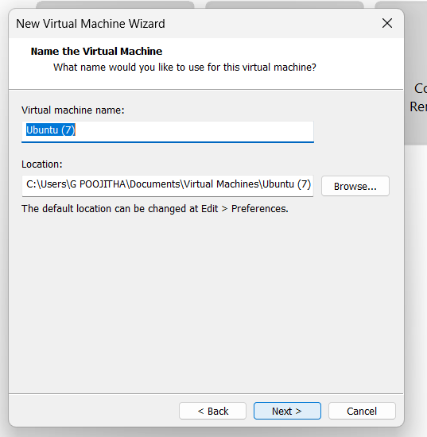
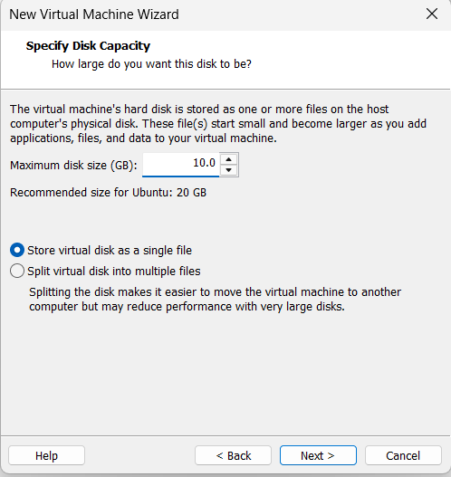

Name it anything→click on next→Adjust the size of disk → change the option to first and then click on next.
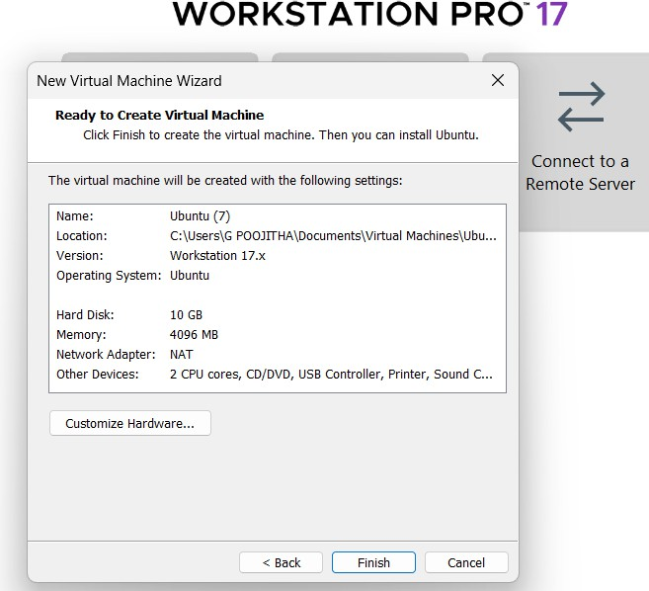
Click on Finish to Launch .

- VM is created
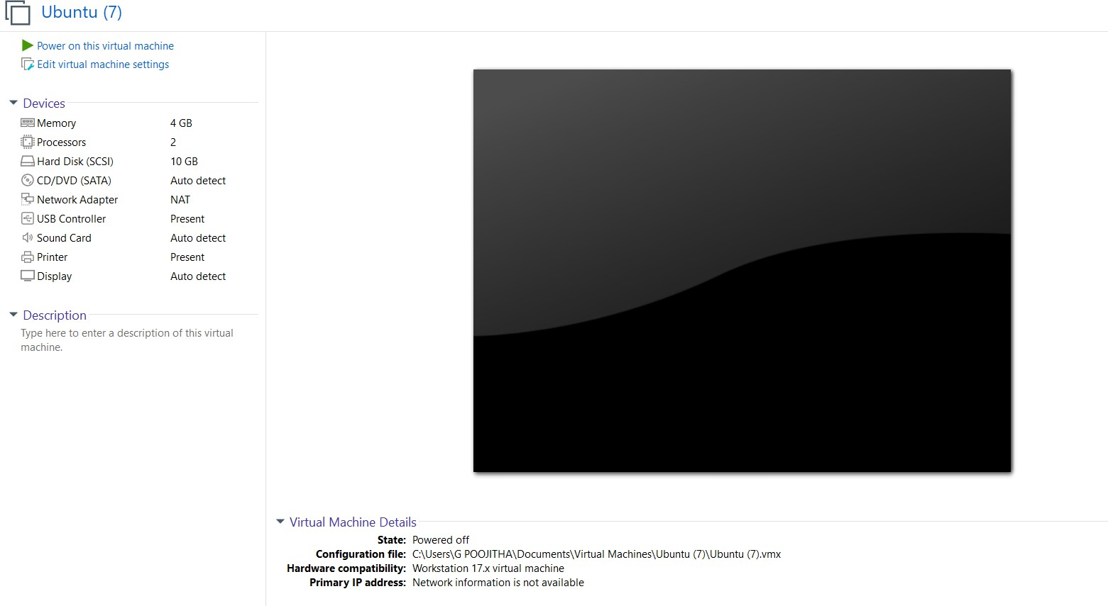
- Double-click on processors and Change number of Processors.
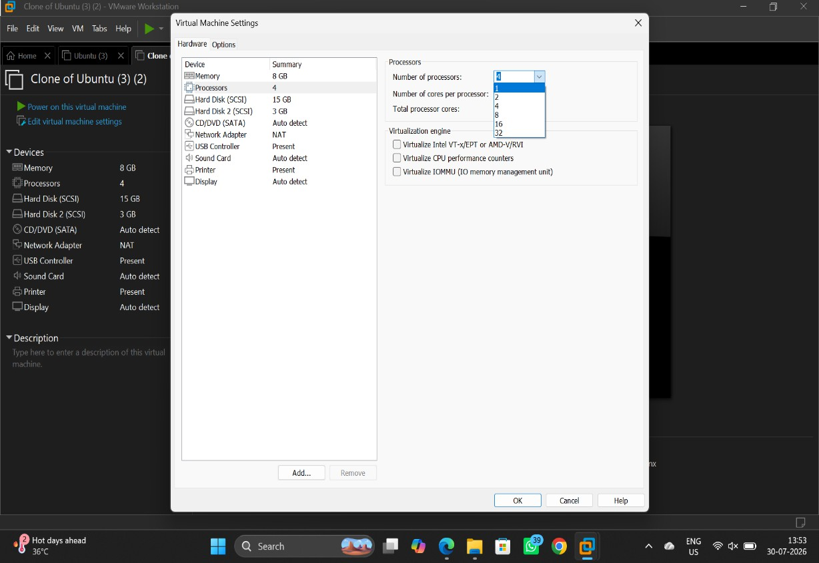

- Click on hard disk and Change storage of hard disk.
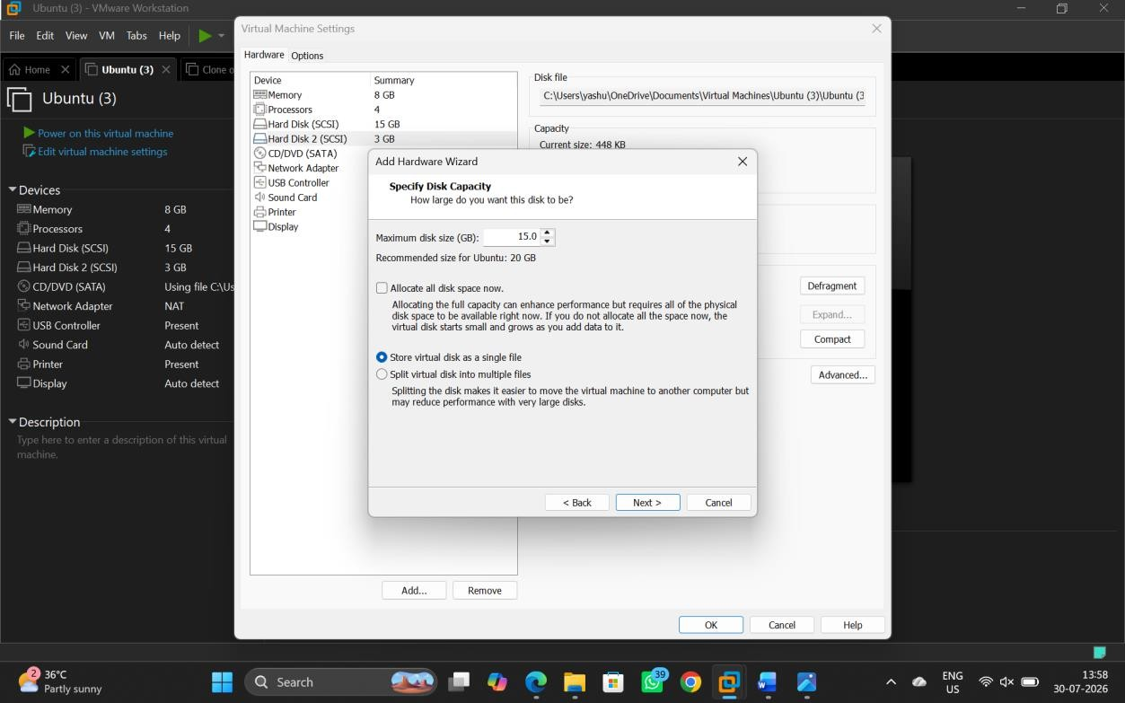

- Click on memory and change size of the memory
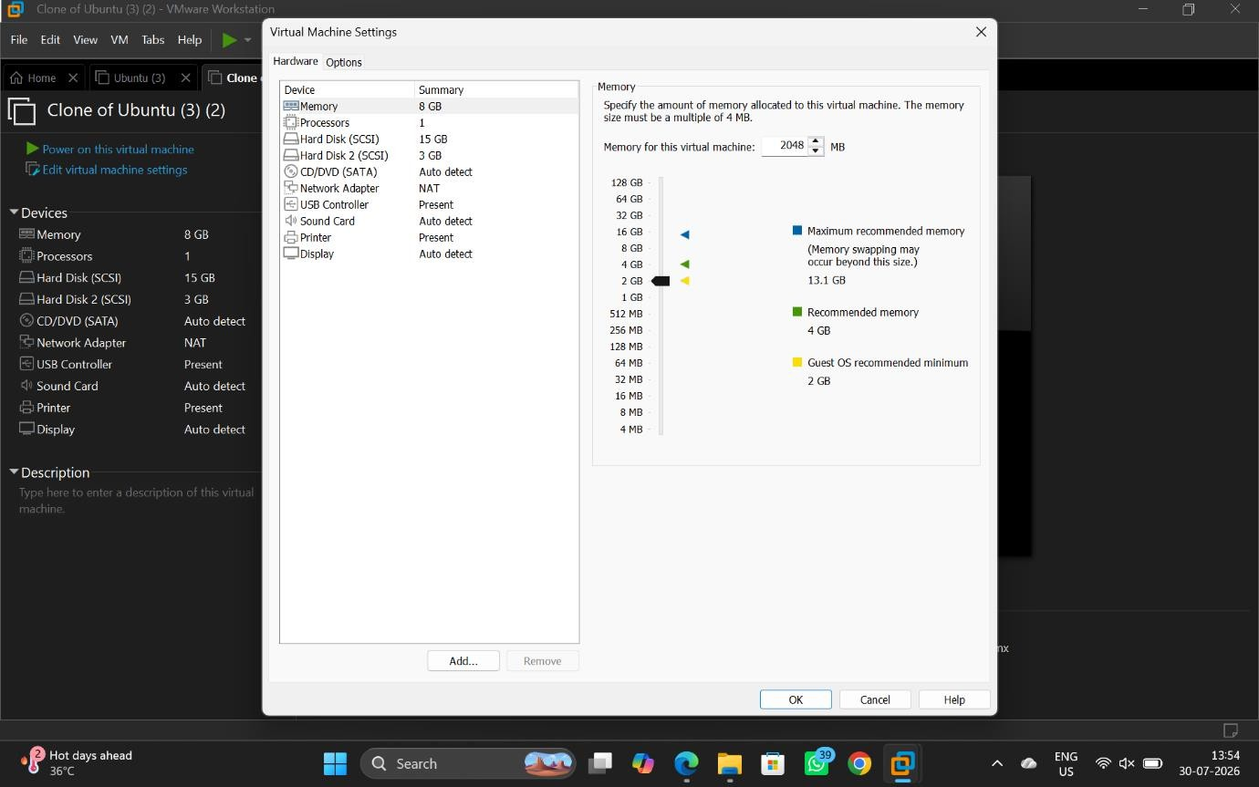

- VM is created according to the conditions given.
